Report on Pricing Strategy of Skiing Ticket for Big Mountain Resort

Yang Li 12/8/2020

# **Introduction**

Big Mountain Resort is a ski resort located in Montana. The resort desires to understand the impacts of the resort features on ticket prices, and plans to make the best pricing strategy to maximize net revenue for the next season to come.

# **Data**

The Database Manager at Big Mountain Resort, Alesha Eisen, provided the data set collected from most of the U.S. ski resorts. The data set includes state and region information, geographic statistics data, operating conditions, facilities and resources, and prices, etc. Moreover, the state population and size information where each resort is located was also combined into this data set. All the ski resorts in Montana have similar weekday prices and weekend prices, so only weekend prices are considered as the target feature for prediction. Principal component analysis (PCA) of the presented data set indicates little relevance between the ticket prices and the states, as shown in Figure 1, therefore all states were treated equally.

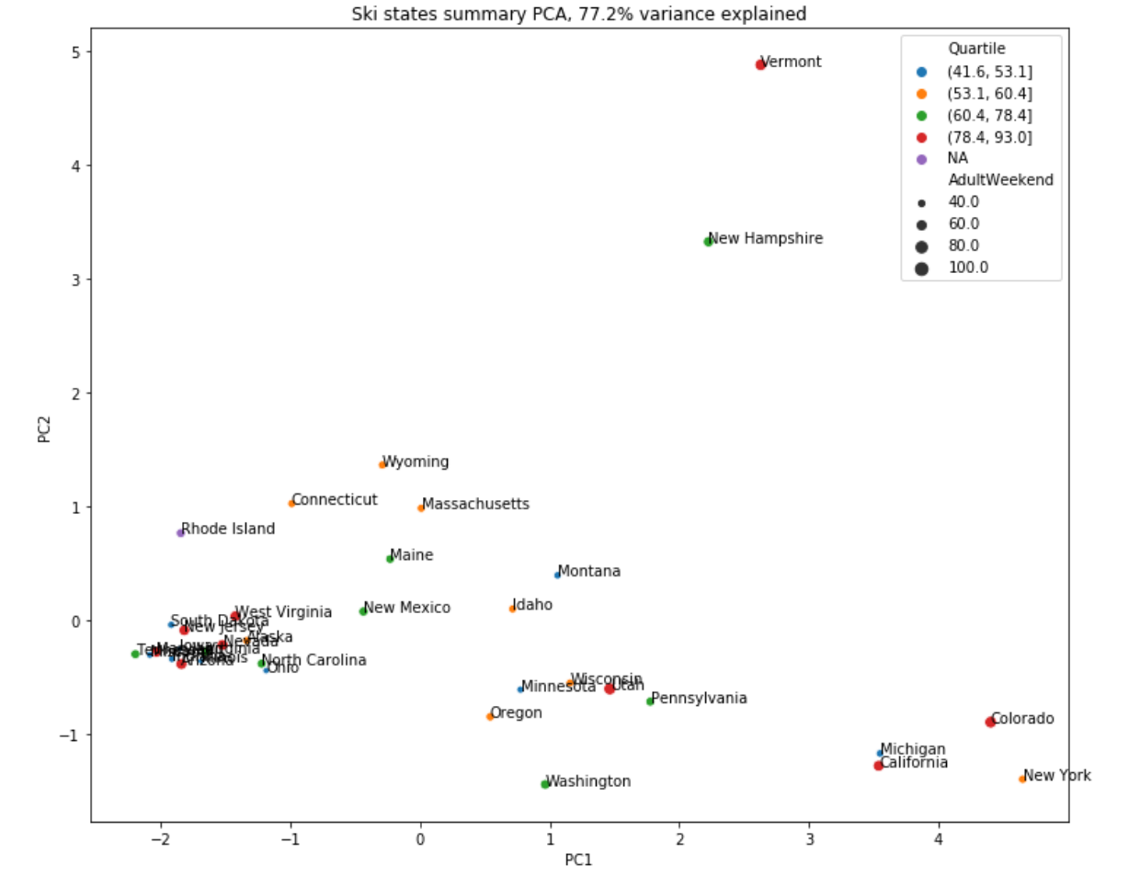

Figure 1. PCA summary plot of the ski resort ticket prices grouped by states. It indicates an irrelevant feature between states and ski resort prices.

A linear regression model and a random forest regression model were adopted on the data set. Performance of models was evaluated by a cross-validation technique, and random forest regression mode prevailed by $0.84 of mean absolute error of the ticket prices, and less variability. The random forest regression model was selected for the modeling and the model was trained by the data from all of the ski resorts except Big Mountain Resort. The size of the data set was proven to be sufficient for this model.

# **Discussion**

The random forest regression model exhibits satisfactory performance on this project. The price’s mean absolute error in average from cross validation on 30% test data is $9.66 and it’s standard deviation in average is $1.35. The model has been trained on the whole data set except the Big Mountain Resort data. With the help of this model, Big Mountain Resort’s predicted ticket price ($94.22±10.39) was calculated. Considering the current ticket price of $81.00, it seems that the resort might be undercharging. In other words, current features of Big Mountain Resort have already been able to support a higher ticket price, resulting in a 16.32% improved net revenue. This can be demonstrated by the fact that Big Mountain Resort owns many top quality facilities and features, while the price is only moderate compared to all the other resorts in the U.S.

The net revenue of Big Mountain Resort could be further improved by implementing various potential scenarios, e.g. changes of some features that have significant impact on prices. The random forest regression model is able to give different levels of importances of the features on prices, as shown in Figure 2.

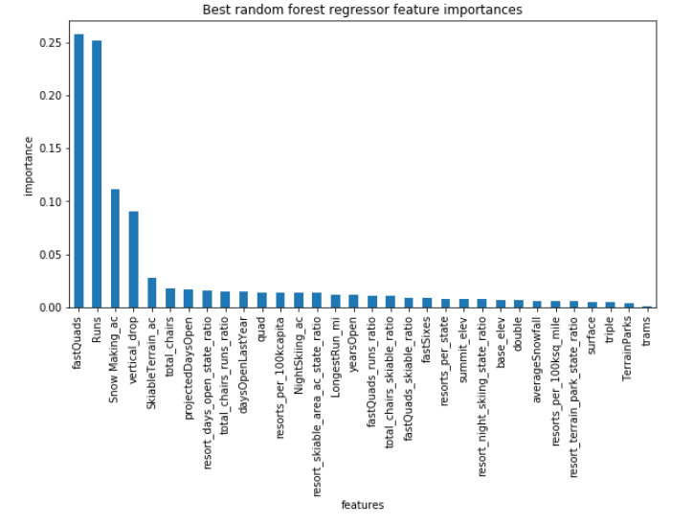

Figure 2. Feature importances from the random forest regression model.

Not all features have the same importance on prices. Some features potentially affect the prices more, such as fast quads, runs, snow making area, vertical drop, ski-able terrain area, etc. Here we are able to use the model to simulate changes of prices according to different scenarios.

For instance, one alternative is adding one run and one chair lift, and increasing vertical drop by 150 feet. This scenario is able to support ticket prices by $1.99. Operating one more chair lift requires $1,540,000 operation cost per season. Assuming 350,000 visitors came and each visitor bought a 5-day pass in average, the ticket price would need to increase $0.88 to cover that cost. The net revenue increase would be $25,077,500. If the number of visitors didn’t change from this season to next season, 17.69% of net revenue increase would be expected.

There are other possibilities. However, not all changes have significant impacts. If the business added one run, one chair lift, increased vertical drop by 150 feet, and also added 2 acres of snow making area, the predicted price increase would be still $1.99. If the business increased the longest run by 0.2 miles and added 4 acres of snow making capacity, the predicted price increase is zero. The detailed prices and revenues are listed in Table 1.

Table 1: Detailed prediction of prices and revenues for Big Mountain Resort.

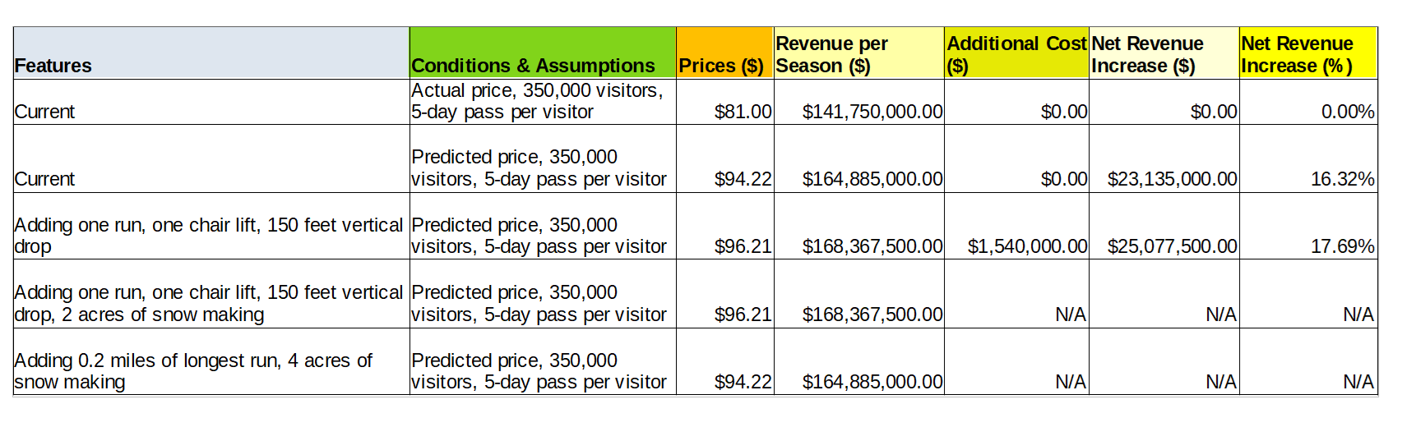

Another way of increasing net revenue is cutting the operating cost. The model tells us that if the business closed several least used runs, the predicted prices would drop, but not in a linear way, as shown in Figure 3. If we knew the operating cost of each run, we might find an optimized point of how many least used runs we should close to maximize the revenue. Unfortunately at this moment, the cost of each run is not available.

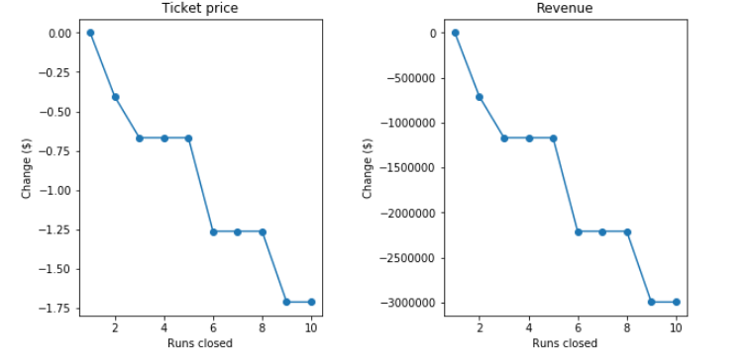

Figure 3: The changes of predicted price and revenue against how many runs closed.

There are other limitations of the present data set that could hamper the simulation result. For instance, the information about numbers of visitors of all the other resorts is missing. Under this circumstance, the price information solely cannot reflect revenues for each resort. Also it seems likely that if the business increased the ticket prices, the number of visitors might decrease because some people would prefer a cheaper ski resort. It’s ideal to obtain more features and to train the proposed model on a continuous basis. The accuracy and robustness of the model will be improved.

# **Conclusion**

A random forest regression model was used to simulate the ticket price for Big Mountain Resort in Montana. A data set that includes most of the U.S. ski resorts has been used to train this model. If no features of Big Mountain Resort changed, the predicted ticket price has already been higher than the actual price. One proposed business scenario is to add one run, add one chair lift, and increase vertical drop by 150 feet, which results in a $1.99 predicted ticket price increase. If 350,000 visitors came and one visitor bought a 5-day pass in average, it counts for an increase of 17.69% net revenue.